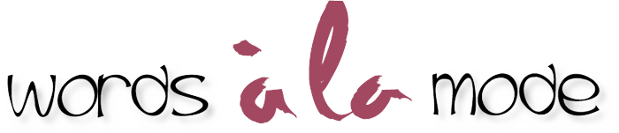

Preferred references for Copyediting/Proofreading
A good dictionary
The Chicago Manual of Style – free monthly Q&A. The print edition requires a comprehensive knowledge of English grammar, punctuation and style. The bible for book publishing.
AP Style Guide (and other style guides, depending on the client) – this is for journalism, not books
A good style and usage manual
Write Right by Jan Venolia
Rewrite Right by Jan Venolia
Online grammar and punctuation blogs, such as:
Grammar Girl’s Quick and Dirty Tips www.quickanddirtytips.com/grammar-girl
If you want more in-depth explanation, this blog is excellent: www.dailywritingtips.com
I find that a lot of comment on grammar blogs is “I think” rather than “I know,” leading to unhelpful discussion, even antagonism. So choose your preferred authorities carefully.

From Flo Selfman
PR Consultant
Proofreader-Copy editor www.wordsalamode.com
flo@wordsalamode.com
President, Independent Writers of SoCalif. www.iwosc.org

