Phantastic Fiction
A Shamanic Approach to Story
© 2015 Matthew J. Pallamary

The Moving Crucible

The definition of a story is conflict and it should be advanced with every word, phrase, sentence, paragraph, and calculated punctuation. Everything should flow toward rising conflict that sparks a confrontation and an explosion which either brings the story to its conclusion, or leaves things flying headlong toward a still bigger conflict that comes to a conclusion or leads to an even bigger clash. This is the rhythm. This is the pace. This is the heartbeat of storytelling.

SYNTHESIS

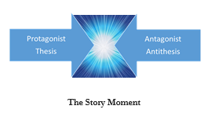
"Everything is energy and that’s all there is to it. Match the frequency of the reality you want and you cannot help but get that reality. It can be no other way. This is not philosophy. This is physics.”

This popular quotation is often attributed to Albert Einstein, but is widely believed to come from a channeler named Darryl Anka who assigned the words to an entity named Bashar.
Nonetheless, as a writer, if you can create the frequency of the reality you want with your words, you cannot help but create that reality in the hearts and minds of your readers.

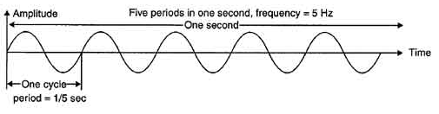

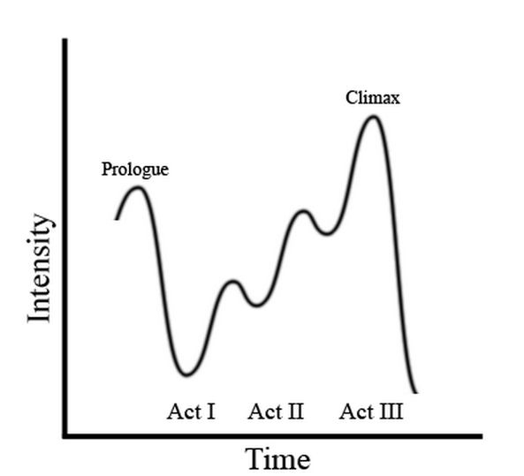
The supporting characters in a story mirror the different aspects and sub-personalities of the protagonist, providing them with reflections of their inner world. The outer world is a reflection of the inner, much of which is shadow, good and bad. Some of the reflections can be beautiful, but many are undesirable and denied. It is said that when certain people in our lives annoy us, it is because they reflect a shadow part of ourselves that we deny, so not only do they reflect what is inside of us back to us, but we project the unwanted parts onto them to avoid seeing it in ourselves.

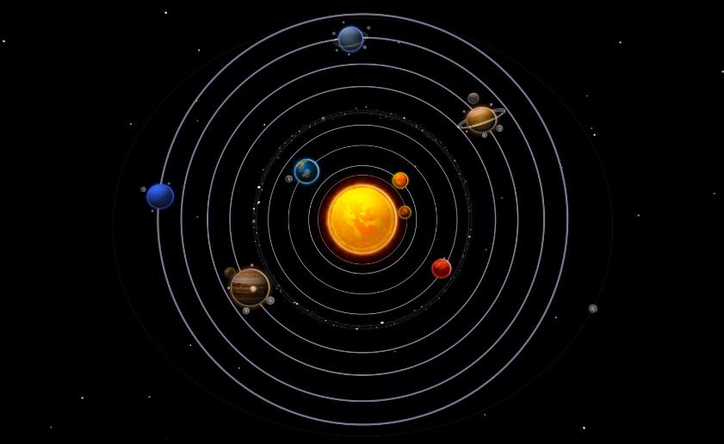
Character Universe

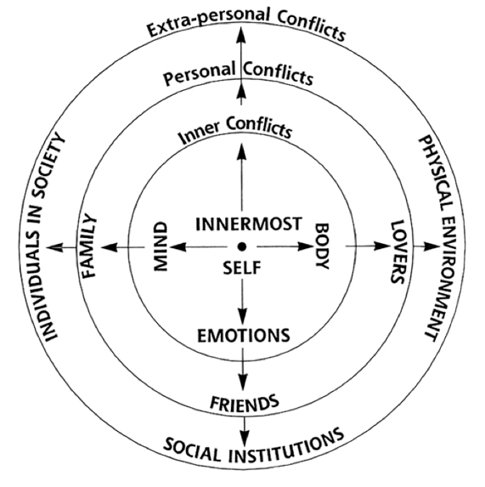
From Robert McKee’s “Story”
The beginning of the Hero's Journey starts with an inciting incident that upsets the balance of the protagonist’s life and ignites their quest to restore the balance.

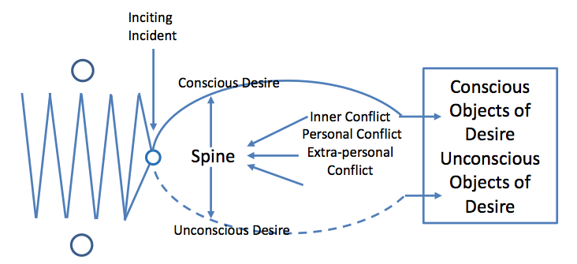
From Robert McKee’s “Story”

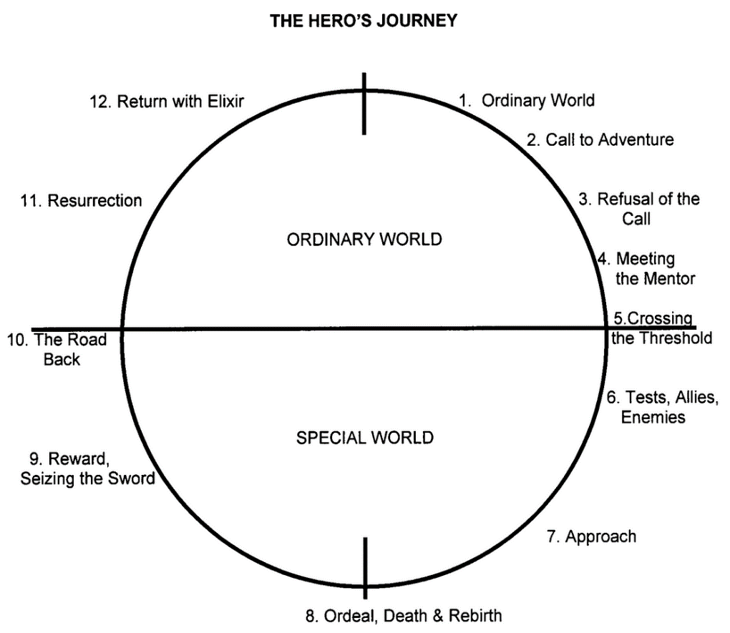

From Vogler’s “The Writer’s Journey:
Mythic Structure For Writers”

