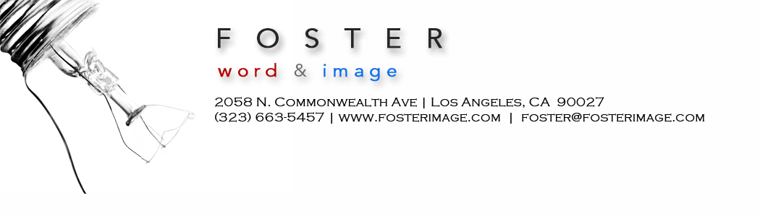

Sample Query Letters | 805 Writers’ Conference

Dear ______,

In an era of mega-budget Halloween attractions, a Los Feliz neighborhood has discovered the ultimate fright: a 16-year-old’s imagination.

Timur Bootzin and his teenage crew have mastered the art of low-budget horror, encircling Timur’s home with a haunted maze, now back for its fifth year.

Timur and 20 friends stage the backyard maze the last three weekends in October, and on Halloween night. The requisite zombies, clowns, and gorillas pop out from hidden corners in a labyrinth built from black sheeting.

At age 12, Timur launched his donation-based attraction with a tent built from garbage bags and strung with body parts. The enterprise steadily grew, fueled by his tenacity and guided by his parents, Dan and Beth.

Timur’s parents describe their son as an irrepressible entrepreneur who expertly manages his teenager actor-zombie crew. He creates rules, holds meetings, ensures safety, and even makes his actors sign contracts.

A week after last year's event, TImur took his dad to breakfast and laid out blueprints for this year's maze. "You just tore the last one down," his dad said. "Give me a break."

Please let me know what you think of this proposed 700-word feature.

________________

< second query letter >

For many wine sophisticates, “Southern California wine” is an oxymoron.

The criticisms of the wines, much of it produced in Temecula, are vast, and have been brewing for decades.

The wines too sweet, the aromas are funky, they lack the complexity and flavor found in wines from Napa or even Paso Robles.

Now a core group of Temecula winemakers is determined to challenge the longstanding belief that the region is only good for bachelorette limo tasting tours and subpar wine. Five wineries have joined forces to beat back the persistent jeers leveled at Temecula Valley’s 33,000-acre American Viticultural Area.

During the past several years, several among Temecula’s forty wineries have invested heavily in tech, education and infrastructure, including deficit irrigation practices.

They are determined to create “wine by the numbers” to counter spiked pH levels caused by a warmer climate and drier soils. Last year, five wineries jointly purchased a $58,000 Oenofoss machine that analyzes wine chemistry.

Their efforts may be starting to pay off. South Coast Winery has won California State Winery of the Year four times, along with 2,500 medals in domestic and international competitions. Serious wine geeks are weighing in: Robert Renzoni Vineyards' 2013 Sonata was just listed by Frank Manglo as among the top 10 wines of 2016.

Temecula boosters have been comparing the region to Napa –– known as a cheap jug wine region before its “Judgment of Paris” moment in 1976. That year, Napa wines bested French during a famous face-off.

This 1,300-word article will detail other factors that have turned wine connoisseurs against the region, as they liken its offerings to “fruit bombs.” I’ll also explain how the region’s formidable wine tourism engine ($696 million in annual visitor dollars), has contributed to Temecula’s reputation as a lightweight “wine playground.”

I’ll include such experts as James Laube, senior editor for Wine Spectator, Matt Kettmann, contributing editor for Wine Enthusiast Magazine, and Ray Johnson, executive director of the Wine Business Institute.

Please let me know what you think.

________________

