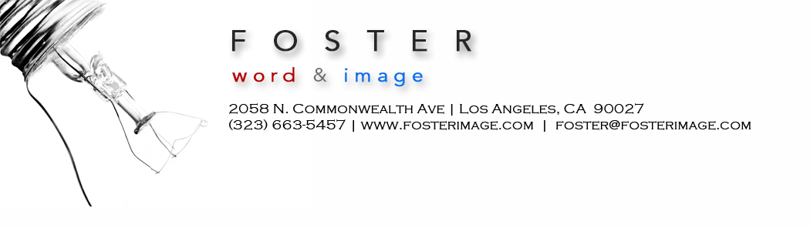

Developing an editor relationship | 805 Writers’ Conference

First know this: editors are overwhelmed, and understaffed. They don’t have time for you ––– unless:

• You can prove that you are of value to them.

Then, and only then, will editors need you. They have story pipelines to fill. They crave not only great, but irresistible ideas.

Make their job easy.

- Deliver irresistible ideas, consistently
- Deliver clean copy that needs little editing
- Deliver on deadline
- Deliver no drama
- Deliver short emails

If you deliver, you will build an editor relationship, the most valuable component of your writer-entrepreneur career. Then, editors will come knocking on your door, asking you to write assignments.

In one sense, you are only as good as your last article. Yes, we can all stumble a bit, and maybe a certain article proves more vexing than others. But on the whole, you need to deliver consistency. No fuss. No muss. That is what editors value.

You need to make an editor’s job easy. And you need to deliver an easy editor-writer relationship. When an editor thinks of you, they should be thinking, oh I just love working with ––––– .

Your goal is to have editors come to depend on you, and also trust in you.

Keep your writer-editor relationship mostly business. Editors don’t need another friend; they have plenty of friends.

This is business. You can stretch this a bit, and there may be some slight exceptions. Follow an editor’s lead.

You don’t need to be dry in your communications; you can be fun here and there. But monitor that line. Editors don’t have time to banter too long about your latest overseas trip. Keep things yes, sometimes fun and engaging in emails and calls ––but also brief. Remember, editors are, nearly always, overwhelmed.

Leave editors alone.

You may have pitched an editor, even one you’ve long known, and they have not responded –– in over a month.

Do not email them, asking if they have received your idea. They have received your idea, believe me. But they did not like your idea, and that is why they have not responded. Yes, perhaps they are yet mulling it over for a future issue. Let them mull it over.

You can eventually bring up the neglected idea, but it’s best done in conjunction with something else –– during a future correspondence. Slip it in.

Editors hate writers who pester them. Do not pester editors. Leave them alone, and they will value you for this quality.

Never call an editor. Always email an editor. They don’t have time for your call (unless they’ve called you first), and they barely have time for your email, unless you are offering something of value.

Become familiar with your editor’s schedule. Know the best time to email him or her, which would most likely be after a publication deadline. Sometimes you can surmise an editor’s schedule because of the predictable day on which they reach out to you. Or simply ask: what’s the optimal time for to handle correspondence? You want your pitches to land on receptive ground.

Anticipate an editor’s hunger –– for stories on an upcoming trend or event / holiday that they need to fill out with good stories.

In short, think like an editor –– and you will go far.

All of your pitches to an editor should be quite close to the bulls eye mark. If you consistently pitch ideas that don’t even land on the larger target, editors will begin to distrust you. They don’t have to buy all your ideas, but they should observe that you are well within the ballpark of what their publication will print.

Editors leave. They leave publications all the time. And so you will need to build a new editor relationship, If possible, ask for an introduction to that editor, before the departing editor leaves. This recommendation can be invaluable. Sometimes, you can follow the former editor to a new publication.

